**Machine Learning Engineer Nanodegree**

**Capstone Proposal**

Omar Castro  
June 13th, 2018

**Proposal**

### Domain Background

Robot learning, which according to the definition in Wikipedia is a research field at the intersection of machine learning and robotics [1], has attracted a great deal of attention over the last years. Self-driving cars, self-flying drones, and autonomous robotic vacuum cleaners are becoming familiar objects in our daily lives. However, teaching robots even the most basic skills is still a daunting task, requiring thousands of trials, highly trained specialists and huge computing resources.

For emerging economies, with scarce resources and different needs from those of developed economies, where most of the research is carried out, handling robot learning requires a frugal approach. The domain background of the project I propose concerns frugal robot learning, employing very low-cost hardware. The main problems of cheap robot hardware are fast tear and wear, high levels of noise, and little availability of sensors or sensor feedback in general. Therefore, frugal robot learning requires data efficient learning strategies that allow the robot to learn in as few trials as possible, taking noise into account, and with light algorithms in terms of computational resources.

Fortunately, data efficient robot learning has been an active topic of research. One of the most cited papers in this area is [2], where Deisenroth and Rasmussen teach a low-cost robot manipulator to perform a basic task with very few trials using PILCO (probabilistic inference for learning control), a data-efficient model-based policy search method [3]. However, PILCO requires large computational times to optimize the policy, since it relies on computationally expensive methods [4]. A more promising approach to achieve frugal robot learning seems to be Bayesian Optimization (BO). Calandra used BO to teach a low cost bipedal to walk with a steady gait [5]. BO is a state-of-the-art model-based approach to optimization under uncertainty.

My personal motivation in choosing data efficient robot learning for my project is twofold: first, I have had a passion for robotics all my life, so being able to teach a robot is something I really enjoy; and second, living in the Dominican Republic, a poor country with failing public services, I believe robots can carry out some of the tasks the government neglects, like public cleaning services. You can’t walk one meter in Santo Domingo that is not polluted with industrial waste. In that sense, I have in mind the idea of designing a self-driving robot that collects industrial waste in public places. I tried to create a basic prototype some time ago, just to find out the huge complexity of the task.

In this project I will address just one of the tasks this robot would do, which is picking the garbage using a robot arm. I plan to take the Robotic Engineer Nanodegree offered by Udacity to have the tools to finish this endeavor, so this project is the first stone towards the final objective. Obviously, robots won’t solve the garbage problem in Santo Domingo, but they can highlight its importance, and contribute to the civic education of the population and the authorities, or at least I hope they would.

### Problem Statement

The problem this project addresses is to teach a very low-cost 6 DOF robot manipulator (US$ 86.99 on Ebay) to grab objects at any discrete position on a plane using a data efficient algorithm. The inputs will be the inicial position of the arm and the angles of the servos in this position, the coordinates of the object to grab, and the coordinates of the container. The tasks to be learned would be the optimal trajectory between the inicial and final positions, grab the object, and drop it on a container.

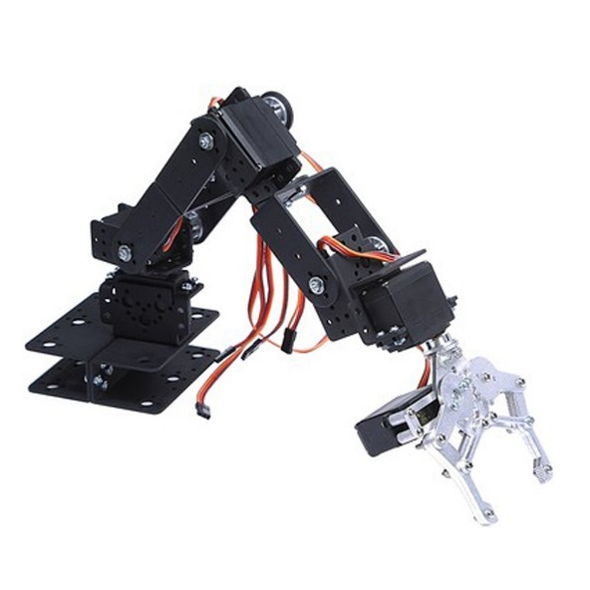

Figure 1: Low cost 6 DOF robot arm by SainSmart

To manipulate the robot arm, I will use the robot controller EZB-V4, which according to their creators, powers more than 20, 000 robots worldwide [5]. The controller costs US$ 79.99 on the web page of ezrobot. The choice of EZB-V4 was a convenient one since I already had one unit which I used to build robots as a hobby. The software that controls EZB-V4, Ez-Builder [6], is a free application provided by the same company to interact with robots. The application allows to set the angles of the servos, the speed in a scale from 0 to 10, and the time the action takes place.

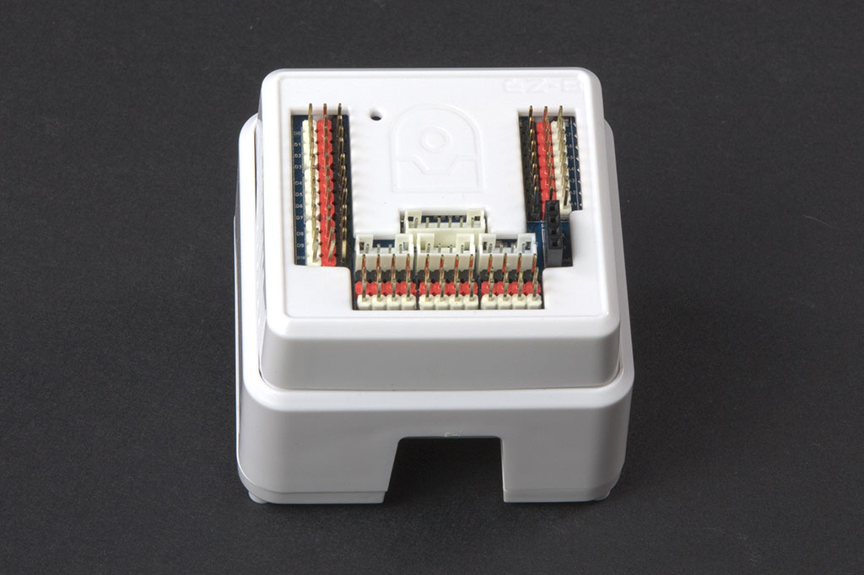

Figure 2: Robot controller EZB-V4 by ezrobot

The main measures of success of this problem are the quantity of objects the arm can grab by number of trials, the quantity of objects dropped inside the container by number of grabbed objects, and the number of trials to learn the behavior. The main objective of the project is to use an algorithm that allows to minimize the number of trials, that takes noise into account (the arm is very noisy, both on vertical and horizontal movements, with fluctuations of more than 1 cm relative to the final aim in a repetitive task using the same parameters).

### Datasets and Inputs

The main dataset used in the project will be generated by the movement of the arm itself. The dataset will contain the inicial position of the arm at the beginning of each episode, the angles of the servos and among parts of the arm in this position, the angles of the servos and among parts of the arm during the trajectories, the angles of the servos and among parts of the arm at the final point, and the position of the clamp at the final point. The goal of the task, whether the object was grabbed or not, will be registered also, and the same set of measures will be taken form the position of the object until it is dropped in the bucket.

Since the algorithm chosen will be Bayesian Optimization, which is a model-based approach, I already created a basic model linking the dimensions and angles of the servos and between the corresponding parts of the arm with the coordinates of the clamp on the plane for each combination of angles. Using this model, I generated a series of simulations with different angles of servos, resulting in a database with 400 observations linking angles of the servos, angles between parts of the arm, and final positions of the clamp corresponding to each combination of angles. This dataset was used as input into a polynomial regression model that allows to predict, given the coordinates of the object to grab, the final angles of the 6 servos. This model will be used as input to the Bayesian Optimization algorithm that will optimize the trajectory of the arm given the position of the object. The model to predict the angles given the coordinates of the object was already tested using the real arm, and the positions

### Solution Statement

(approx. 1 paragraph)

In this section, clearly describe a solution to the problem. The solution should be applicable to the project domain and appropriate for the dataset(s) or input(s) given. Additionally, describe the solution thoroughly such that it is clear that the solution is quantifiable (the solution can be expressed in mathematical or logical terms) , measurable (the solution can be measured by some metric and clearly observed), and replicable (the solution can be reproduced and occurs more than once).

### Benchmark Model

(approximately 1-2 paragraphs)

In this section, provide the details for a benchmark model or result that relates to the domain, problem statement, and intended solution. Ideally, the benchmark model or result contextualizes existing methods or known information in the domain and problem given, which could then be objectively compared to the solution. Describe how the benchmark model or result is measurable (can be measured by some metric and clearly observed) with thorough detail.

### Evaluation Metrics

(approx. 1-2 paragraphs)

In this section, propose at least one evaluation metric that can be used to quantify the performance of both the benchmark model and the solution model. The evaluation metric(s) you propose should be appropriate given the context of the data, the problem statement, and the intended solution. Describe how the evaluation metric(s) are derived and provide an example of their mathematical representations (if applicable). Complex evaluation metrics should be clearly defined and quantifiable (can be expressed in mathematical or logical terms).

### Project Design

(approx. 1 page)

In this final section, summarize a theoretical workflow for approaching a solution given the problem. Provide thorough discussion for what strategies you may consider employing, what analysis of the data might be required before being used, or which algorithms will be considered for your implementation. The workflow and discussion that you provide should align with the qualities of the previous sections. Additionally, you are encouraged to include small visualizations, pseudocode, or diagrams to aid in describing the project design, but it is not required. The discussion should clearly outline your intended workflow of the capstone project.

1. https://en.wikipedia.org/wiki/Robot_learning
2. Deisenroth, M. P., Rasmussen, C. E., & Fox, D. (2012). Learning to control a low-cost manipulator using data-efficient reinforcement learning. In *Robotics: Science and Systems.* (Vol. 7, pp. 57-64). MIT Press Journals.
3. M. P. Deisenroth and C. E. Rasmussen. PILCO: A Model-Based and Data-Efficient Approach to Policy Search. In ICML, 2011.
4. Polydoros, A.S. & Nalpantidis, L. J Intell Robot Syst (2017) Survey of Model-Based Reinforcement Learning: Applications on Robotics 86: 153. <https://doi.org/10.1007/s10846-017-0468-y>
5. Calandra, R., Seyfarth, A., Peters, J. et al. Ann Math Artif Intell (2016) Bayesian optimization for learning gaits under uncertainty. 76: 5. <https://doi.org/10.1007/s10472-015-9463-9>
6. <https://www.ez-robot.com/Shop/AccessoriesDetails.aspx?prevCat=9&productNumber=40>
7. <https://www.ez-robot.com/EZ-Builder/>
8. Martinez-Cantin, R., de Freitas, N., Brochu, E. et al. Auton Robot (2009) 27: 93. https://doi.org/10.1007/s10514-009-9130-2
9. Deisenroth, Marc & Edward Rasmussen, Carl. (2011). PILCO: A Model-Based and Data-Efficient Approach to Policy Search.. 465-472.
10. [Jasper Snoek](https://arxiv.org/search?searchtype=author&query=Snoek%2C+J), [Hugo Larochelle](https://arxiv.org/search?searchtype=author&query=Larochelle%2C+H), [Ryan P. Adams](https://arxiv.org/search?searchtype=author&query=Adams%2C+R+P). (2012). Practical Bayesian Optimization of Machine Learning Algorithms. [arXiv:1206.2944](https://arxiv.org/abs/1206.2944)
11. HUSSEIN, A., GABER, M.M., ELYAN, E. and JAYNE, C. 2017 Imitation learning: a survey of learning methods. ACM computing surveys [online], 50(2), article 21. Available from: <https://doi.org/10.1145/3054912>
12. Deisenroth, M.P.; Fox, D.; Rasmussen, C.E. (2014). Gaussian Processes for Data-Efficient Learning in Robotics and Control, IEEE Transactions on Pattern Analysis and Machine Intelligence.